**Gaussian Write-Up**

Thankfully, the most difficult part of this assignment was completed in class. The Gaussian blur itself would have been the hardest part if I had to complete it alone. The greatest difficulty in this assignment was just keeping track of variables as I combined various pieces of old code, such as the binarizing, point operations, and auto thresholding. Thankfully, the program only failed once (I binarized the result of the Gaussian Blur instead of the difference between the two blurs) and after I corrected that mistake, it worked perfectly.

RED

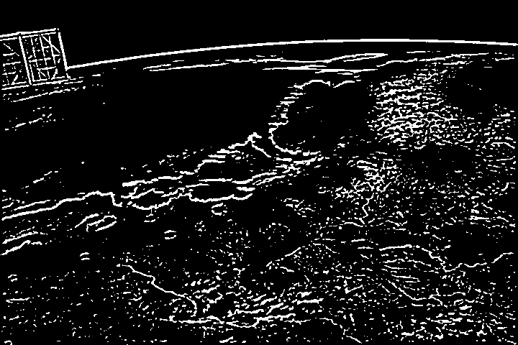

GREEN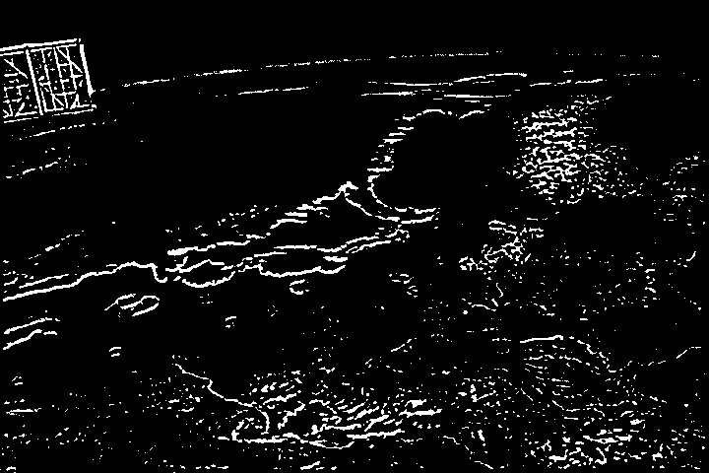

BLUE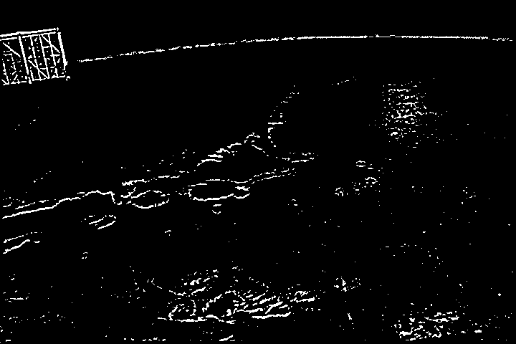

BEFORE THRESHOLDING (For fun)